|  |  |
| --- | --- |
| Name: Varun Khadayate | Subject: Compiler Design |
| Roll No: A016 | Date of Submission: 24th September 2021 |

# Aim

To design shift reduce parser from given grammar. (shift reduce)

# Program logic

## Shift Reduce parser

attempts for the construction of parse in a similar manner as done in bottom up parsing i.e. the parse tree is constructed from leaves(bottom) to the root(up). A more general form of shift reduce parser is LR parser.

This parser requires some data structures i.e.

* A input buffer for storing the input string.
* A stack for storing and accessing the production rules.

### Basic Operations –

#### Shift

This involves moving of symbols from input buffer onto the stack.

#### Reduce

If the handle appears on top of the stack, then, its reduction by using appropriate production rule is done i.e. RHS of production rule is popped out of stack and LHS of production rule is pushed onto the stack.

#### Accept

If only start symbol is present in the stack and the input buffer is empty then, the parsing action is called accept. When accept action is obtained, it is means successful parsing is done.

#### Error

This is the situation in which the parser can neither perform shift action nor reduce action and not even accept action.

## Example 1

Consider the grammar   
        S –> S + S   
        S –> S * S   
        S –> id

Perform Shift Reduce parsing for input string “id + id + id”.

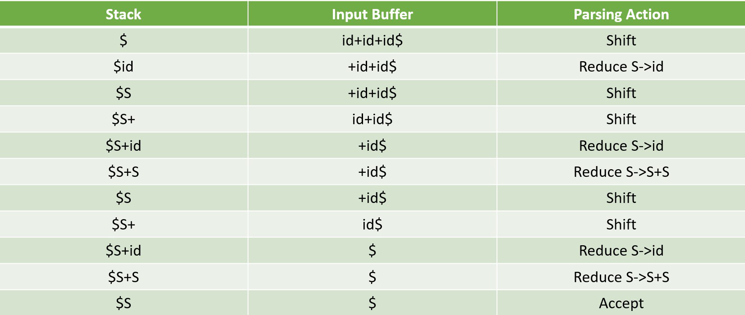

## **Example 2**

Consider the grammar   
        E –> 2E2   
        E –> 3E3   
        E –> 4   
Perform Shift Reduce parsing for input string “32423”.

Lightbox

## **Example 3**

Consider the grammar  
                         S –> ( L ) | a          
                         L –>  L , S | S      
Perform Shift Reduce parsing for input string “( a , ( a , a ) ) “.

| **Stack** | **Input Buffer** | **Parsing Action** |
| --- | --- | --- |
| **$** | **( a , ( a , a ) ) $** | **Shift** |
| **$ (** | **a , ( a , a ) ) $** | **Shift** |
| **$ ( a** | **, ( a , a ) ) $** | **Reduce S → a** |
| **$ ( S** | **, ( a , a ) ) $** | **Reduce L → S** |
| **$ ( L** | **, ( a , a ) ) $** | **Shift** |
| **$ ( L ,** | **( a , a ) ) $** | **Shift** |
| **$ ( L , (** | **a , a ) ) $** | **Shift** |
| **$ ( L , ( a** | **, a ) ) $** | **Reduce S → a** |
| **$ ( L , ( S** | **, a ) ) $** | **Reduce L → S** |
| **$ ( L , ( L** | **, a ) ) $** | **Shift** |
| **$ ( L , ( L ,** | **a ) ) $** | **Shift** |
| **$ ( L , ( L , a** | **) ) $** | **Reduce S → a** |
| **$ ( L , ( L , S )** | **) ) $** | **Reduce L →L , S** |
| **$ ( L , ( L** | **) ) $** | **Shift** |
| **$ ( L , ( L )** | **) $** | **Reduce S → (L)** |
| **$ ( L , S** | **) $** | **Reduce L → L , S** |
| **$ ( L** | **) $** | **Shift** |
| **$ ( L )** | **$** | **Reduce S → (L)** |
| **$ S** | **$** | **Accept** |

# Lab Assignment

## What is shift reduce Parser

A shift-reduce parser is a class of efficient, table-driven bottom-up parsing methods for computer languages and other notations formally defined by a grammar. The parsing methods most used for parsing programming languages, LR parsing and its variations, are shift-reduce methods.

## What are different types?

There are two main categories of shift reduce parsing as follows:

1. Operator-Precedence Parsing
2. LR-Parser

## Specify rules shift reduce parser.

#### Shift

This involves moving of symbols from input buffer onto the stack.

#### Reduce

If the handle appears on top of the stack, then, its reduction by using appropriate production rule is done i.e. RHS of production rule is popped out of stack and LHS of production rule is pushed onto the stack.

#### Accept

If only start symbol is present in the stack and the input buffer is empty then, the parsing action is called accept. When accept action is obtained, it is means successful parsing is done.

#### Error

This is the situation in which the parser can neither perform shift action nor reduce action and not even accept action.

## Define algorithm for shift reduce parser.

1. Get the input expression and store it in the input buffer.
2. Read the data from the input buffer one at the time.
3. Using stack and push & pop operation shift and reduce symbols with respect to production rules available.
4. Continue the process till symbol shift and production rule reduce reaches the start symbol.
5. Display the Stack Implementation table with corresponding Stack actions with input symbols.

# Lab Assignment Program

Write a program to design a shift reduce parser from given grammar. (shift reduce)

## Code

gram = {

    "S":["S+S","S*S","id"]

}

starting_terminal = "S"

inp = "id+id*id"

stack = "$"

print(f'{"Stack": <15}'+"|"+f'{"Input Buffer": <15}'+"|"+f'Parsing Action')

print(f'{"-":-<50}')

while True:

    action = True

    i = 0

    while i<len(gram[starting_terminal]):

        if gram[starting_terminal][i] in stack:

            stack = stack.replace(gram[starting_terminal][i],starting_terminal)

            print(f'{stack: <15}'+"|"+f'{inp: <15}'+"|"+f'Reduce S->{gram[starting_terminal][i]}')

            i=-1

            action = False

        i+=1

    if len(inp)>1:

        stack+=inp[0]

        inp=inp[1:]

        print(f'{stack: <15}'+"|"+f'{inp: <15}'+"|"+f'Shift')

        action = False

    if inp == "$" and stack == ("$"+starting_terminal):

        print(f'{stack: <15}'+"|"+f'{inp: <15}'+"|"+f'Accepted')

        break

    if action:

        print(f'{stack: <15}'+"|"+f'{inp: <15}'+"|"+f'Rejected')

        break

## Output

